Accessing Beacon treatment plan section
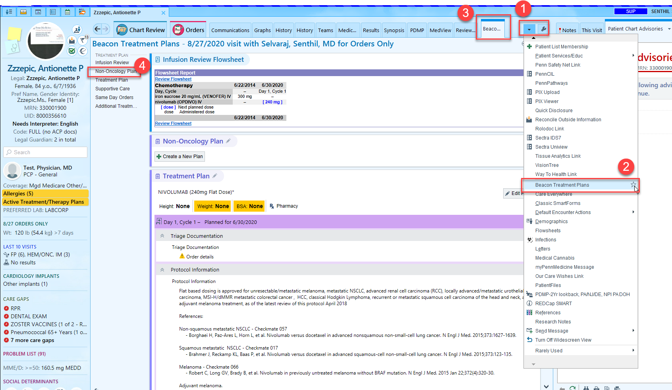

- Click on the divot.
- Scroll down the list to bring up the Beacon Treatment Plans and
- Click on the star so that moving forward the Beacon Treatment Plan section will always appear in your activities tabs.
- Click on the Non-Oncology Plan within the navigator section
- In some cases, when first accessing the Beacon Treatment Plans the user may have to click on “Rarely Used” (see below).

Click on inverted triangle (1), then many users will have to click on “Rarely used” (2) at the bottom of the list and then on “Beacon Treatment Plans” (3)

